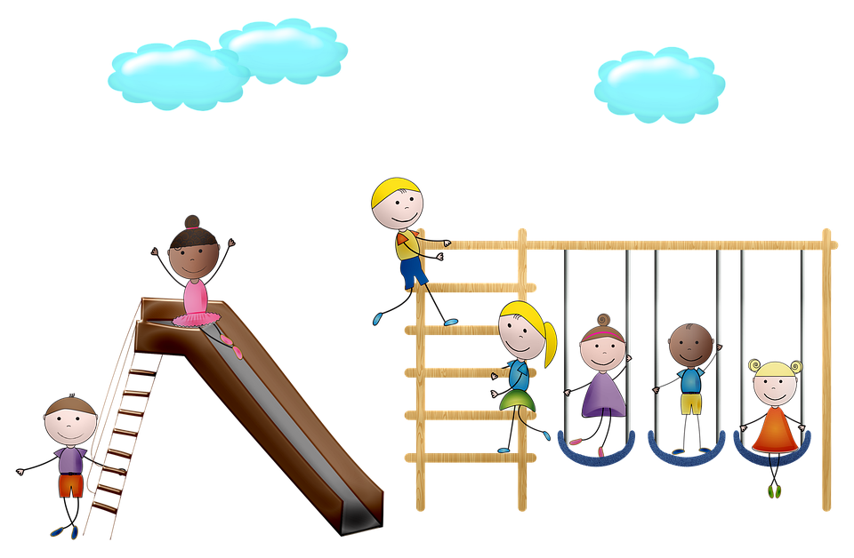**Nancy Cory School**

**Recess & Lunch Schedule**

**2023-2024**

**Morning Recess**

**UTK/Kindergarten: Grade 1 & Grade 2:**

9:20-9:35 AM - K-2(Edwards) K-1 (Open TK) & K-3(Upah) 9:50-10:05 AM

9:35-9:50 AM - K-7(Andreoli) & K-6(Hill)

**Grade 3:** **Grade 4 & Grade 5:**

10:05-10:20 AM 10:20-10:35 AM

**Afternoon Recess**

**Kindergarten: Grades 1 & 2:**

1:05-1:18 PM - K-2(Edwards) K-1(Open TK) & K-3(Upah) 1:30-1:43 PM

1:15-1:28 PM - K-7(Andreoli) & K-6(Hill)

**Grade 3:**

1:45-1:58 PM

**Lunch**

**Kindergarten**: K-2(Edwards) K-1 (Open TK) & K-3(Upah) 11:05-11:55 AM

**Lunch: 11:05-11:30**

Recess: 11:30-11:55

**Grade 1:** 11:15-12:05 PM

**Kindergarten**: K-7(Open) & K-6(Hill) 11:05-11:55 AM

Recess: 11:05-11:30

**Lunch: 11:30-11:55**

**Grade 4:** 11:40-12:25 PM

**Grade 2:** 11:55-12:45 PM

**Grade 3:** 12:10-1:00 PM

**Grade 5** 12:25-1:10 PM